Women History Month: CSM Jasmine N. Young

“Women Who Have Made Great Achievements”

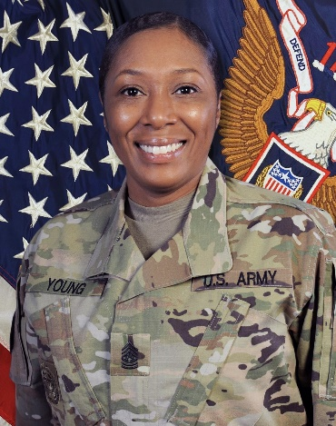

Introduction: The Army is one of the most diverse organizations in the United States. Every month the Army celebrates the diversity in its ranks. March is no exception as the service pays tribute to the women who, through their determination and contributions, have shaped America’s history and whose efforts continue to pave the way forward and contributing on Women’s History Month.

CSM Jasmine Young, is currently serving as the 13th Adjutant General Regimental Command Sergeant Major at the U.S. Army Soldier Support Institute.

Introduce yourself, who you are, where you from, where you work and what you do in the military.
- Tell us a little bit about yourself:
I am CSM Jasmine N. Young. As a military child, I hail from Fayetteville, North Carolina and have been a Human Resource professional and a part of the Adjutant General Corps for over 20 years. I am the 13th Adjutant General Corps Regimental and School Command Sergeant Major and the 4th to serve as a woman at the Soldier Support Institute. I pride myself on being a leader who is versatile, using keen interpersonal skills and intellect to build Teams, solve problems and break new ground.

- Why is important that we celebrate Women’s History Month or what does it mean to you?
I believe it is important to observe and celebrate Women’s History Month because history is where we receive our lessons-learned for continued growth as an institution and as a society. In observance we remember the contributions made by those who have come before us and how those contributions have moved us forward through invention and accomplishment. In celebration we inspire those who will one day replace us all for that same continued growth.

- Who are some Women that have inspired you or had an impact on your life and why?
I believe it was Sir Issac Newton, among others, who penned a phrase that speaks to 'Standing on the shoulders of giants'. I truly believe there have been many women who have inspired me and others to push farther and longer for the betterment of others. I have experienced many “giants” in my lifetime, and I am thankful for their time, wisdom and faith that I too could forge the effort to inspire others.

- What were some challenges that you or others you may know faced during the time in the military and how has the military evolved since then?
We all face challenges. I for one use the experience to help grow as an individual and fuel to ensure those around me or after me will not have to face the same challenges; or when faced with challenges have an example to learn from.

- What made you join the Army?
Both my parents served as enlisted personnel in the Army, it is like a family business for me. I never wanted to do much of anything else, besides be a Soldier because that’s the example I had growing up. My parents modeled behavior and principals that I value today. My mother was a Non-Commissioned Officer so I had an example of women serving in the Army. It was revered and I wanted to do and be like my mother and others.

- How do diverse teams improve our squads?
Diverse Teams really do enhance the Army’s capabilities through different perspectives, ways of thinking, and experience to solve problems. I believe our diversity as an Army is our true strength as a fighting force.

