Women History Month: COL Michelle M. Williams

“Women Who Have Made Great Achievements”

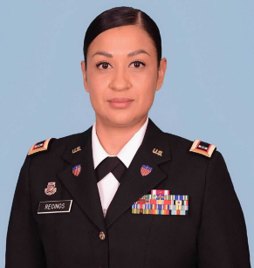

Introduction: The Army is one of the most diverse organizations in the United States. Every month the Army celebrates the diversity in its ranks. March is no exception as the service pays tribute to the women who, through their determination and contributions, have shaped America’s history and whose efforts continue to pave the way forward and contributing on Women’s History Month.

CW2 Jessica Recinos, currently serving as a the IPPS-A Instructor and Developer for the U.S. Army Soldier Support Institute.

Introduce yourself, who you are, where you from, where you work and what you do in the military.
- Tell us a little bit about yourself: My name is CW2 Jessica L. Recinos. I joined at the age of 17 year out of Santa Ana, California. I am a first-generation Hispanic female with Salvadorian background that has been proudly serving for 18 years. I enlisted as a Human Resource Specialist and commissioned to be a Human Resource Technician in 2017. I am currently an instructor at the Adjutant General’s school, providing IPPS-A classes to all three components in the Army.

- Why is important that we celebrate Women’s History Month or what does it mean to you? It is important to celebrate each woman that has risen up into their full potential and faced cultural and systematic hurdles. The unconscious bias still exists and stepping into leadership roles has always empowered women to be seen and heard. Women are strong, powerful individuals that conquer the ability to be enhance anything they set their minds too.

- Who are some Women that have inspired you or had an impact on your life and why? My mother has been my biggest inspiration. She gave us everything she didn’t have and more. Until this day she provides for all her children putting herself second. Growing up and coming from mostly nothing, she provided us with an education, a career, and the unwavering support to allows us to know that we can become and succeed in any career field we wanted.

- What were some challenges that you or others you may know faced during the time in the military and how has the military evolved since then? During my time in the military one of the biggest challenges I have had that I always reminisce on is being a Drill Sergeant and proving to my leaders that I was able to perform side by side to an infantry male. Knowing that women are not built like a man, I repeatedly proved to be as strong and skilled to teach and mentor as well as they did during tactical instructions. Women work twice as hard to prove that we are strong and capable.

- What made you join the Army? The reason why I joined the Army was a female recruiter and her presence at my high school. This female recruited looked badass, and I said to myself, I want to serve and protect my country but also look as cool as she did in uniform. I have always been a leader and the Army has allowed me to fulfill my dream to serve and make a difference in my organizations with unlimited potential to lead and successfully accomplish my missions.

- How do diverse teams improve our squads? Each member of my squad brings innovative ideas and different solutions based on their background and upbringings. Diversity is important to allow different knowledge allowing teams to adapt and better understand what needs to be accomplished. Each member brings something unique to the table and it is important to understand that we are not all made to think the same way, but we can all have the same outcome in a positive environment.

