Women History Month: Mrs. Judith Boyd

“Women Who Have Made Great Achievements”

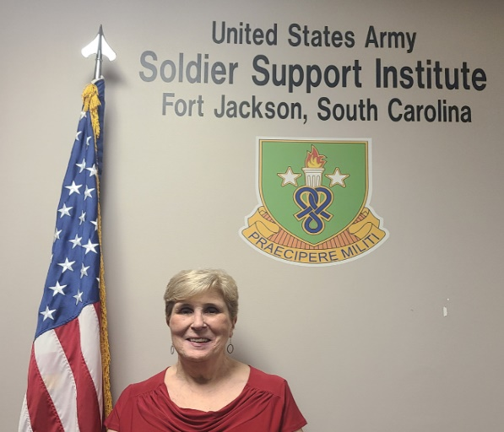

Introduction: The Army is one of the most diverse organizations in the United States. Every month the Army celebrates the diversity in its ranks. March is no exception as the service pays tribute to the women who, through their determination and contributions, shaped America’s history and whose efforts continue to pave the way forward and contribute to Women’s History Month.

Judith F. Boyd currently serves as Quality Assurance Evaluator at the U.S. Army Soldier Support Institute.

Introduce yourself, who you are, where you are from, where you work and what you do in support of the military.
- Tell us a little bit about yourself:

I was born in Pennsylvania while my Dad was in Seminary but moved to Ohio very young and that is where I call home. I served in the Army almost 28 years and have worked Quality Assurance at SSI for over 18 years. My job is to assess training and other functions against the Army Enterprise Accreditation Standards to ensure we do what is right for our Soldiers and DA Civilians. I report my findings to the SSI and USAR leaders, so they know the areas that should be improved. The best thing about my job is I get to work with all components of the Army, travel to some of the training sites and stay involved with Soldiers.

- Why is it important that we celebrate Women’s History Month or what does it mean to you?

It is important to celebrate all of the Women who have accomplished so much. I also think it is important to think about the Women in our lives who also need to be celebrated. They do so much every day that no one ever hears about, but it is so important to our mission and to us. So, celebrate the special Women in your family, your friends and co-workers that so often do not get any special recognition.

- Who are some Women that have inspired you or had an impact on your life and why?

There have been so many wonderful women in my life. But my Mom had the biggest impact. She was the wife of a minister with 5 very active children. I didn’t realize until later in life just how much a ministers wife does that nobody really notices. But she was always there for everyone but especially for us. She gave me a very strong foundation, taught me how to work hard and stand up for what is right.
Other Women who had an impact on my life was MG Patricia Hickerson. I worked as her XO when she was the Deputy Chief of Staff of Personnel and Installation Management for the United States Army Europe and the 7th Army. She had so many “firsts” in her career. She was one of SSI’s Commanders, but more importantly, she was a great leader and mentor.
The other Woman is COL Rose Walker always inspired me by her professionalism, the way she treated her Soldiers and Civilians, and always demonstrating the Army Values. I worked for her when she was the Commander, 1st Personnel Command, U.S. Army Europe & Seventh Army and also indirectly when she was the Commandant of the Adjutant General School and the SSI Commander. She was another very strong Woman, quiet, but very intelligent. She believed in her people and let them do their job. She was another great mentor.
Finally, my two daughters-in-law’s are true inspirations to me. Erin is a teacher at a Monnisori School and is an example to our young children every day. She is so creative, smart and knows what she wants in life. Nicole is a stay-at-home Mom. She raised two beautiful children and then her and my son decided to foster children. I can’t tell you how many children have come through their home because there have been so many. And they don’t take the easy ones. Many of them have had challenging issues. They took 3 siblings who had been abused and the two boys have hemophilia. They still have some challenges from their abuse, but they recently adopted all three of them. They currently have two other foster children so their house always seems very chaotic but Nicole always has it under control. Both Erin and Nicole are so special to me and as a Mom, I couldn’t ask for better wives for my sons.

- What were some challenges that you or others you may know faced during the time in the military and how has the military evolved since then?
We have all faced challenges. I came in the Army a long time ago when the Women’s Army Corps (WAC) still existed, and I wore WAC brass in basic training and had an all-female class here at Fort Jackson. When I arrived at my first duty station, I got promoted to E5 quickly because of my college degree. It was strange being really new to the Army, a female, and in charge of all the men who had been in the Army much longer than me. It was challenging and exciting leading male Soldiers who had more time and experience then I did at the time. Yet, I learned quickly, earned their trust and exceled at my job.
In Officer Candidate School (OCS), the class had about 225 Soldiers but only 15 – 20 were females. My first job was at an Ordnance BN (Ammo) as the S1. The Commander and Deputy did not like women, and it was very obvious. It was a hard assignment until the new Commander came, and everything changed. He was one of the best mentors I had in the Army.
Wow, how times have changed when it comes to having babies. I had a baby while I was in the unit. I gave birth to my son by cesarian and was given 4 weeks of convalescent leave and returned to duty with no limitations. We were a dual military family so we had to find childcare because the daycare did not accept babies until they were 6 weeks. Today's Army takes the entire family into consideration and allows the birth parent and the dual military spouse time off to acclimate as a family unit.
Challenges make you strong and I have faced challenges in both my military and civilian careers while supporting the Army profession and values. My challenges made me stronger and an excellent mentor to others.

- What made you join the Army?
When I graduated from college, my plan was to be a teacher. However, in 1976, teaching jobs were scarce. When the school year started, I did not have a teaching job and hated the job I was doing. So, one day when I passed a recruiting office, I decided to stop. It sounded interesting but I kept thinking, “How am I going to tell Mom?” I visited the Army and Air Force Recruiters, and the Army gave me a much better deal for my college education. I finally did tell my parents and although they were a little concerned about me joining (especially Mom), they did accept it. My original goal was to complete my three years to gain experience and then get out and teach. Then it changed to finish basic training and go to OCS. However, it was 6 years later that I finally went to OCS as an SSG. And as I already said, my original plan of three years lasted almost 28 and I don’t regret any of it. Throughout my active duty and Army Civilian careers, my parents, spouse, and children have and always will be my biggest supporters.

