Women History Month: SSG Glover, Emonee

“Women Who Have Made Great Achievements”

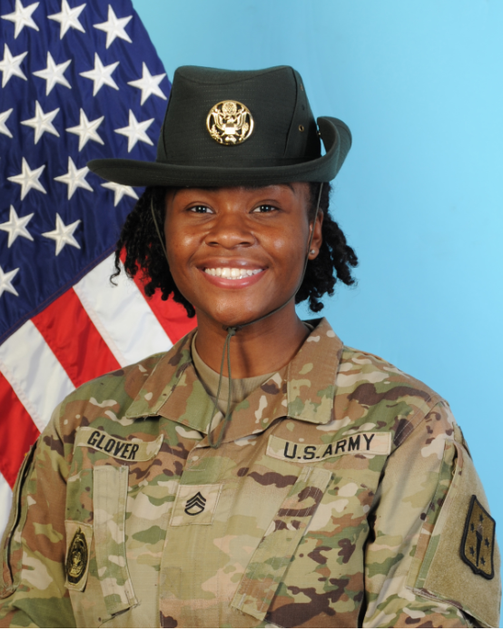

Introduction: The Army is one of the most diverse organizations in the United States. Every month the Army celebrates the diversity in its ranks. March is no exception as the service pays tribute to the women who, through their determination and contributions, have shaped America’s history and whose efforts continue to pave the way forward and contributing on Women’s History Month.

SSG (DS) Glover is currently serving as a Drill Sergeant in Delta Company 369th AG BN.

Introduce yourself, who you are, where you from, where you work and what you do in the military.
- Tell us a little bit about yourself:

I am Emonee Glover, a mother and Intelligence Analyst in the United States Army. I went to Basic Combat training in February 2018. I first served in Grafenwoehr, Germany where I gave birth to my beautiful four-year-old daughter. My hobbies include hiking, painting, and writing. I enjoy motherhood, being a Soldier, and currently, being a Drill Sergeant.

- Why is important that we celebrate Women’s History Month or what does it mean to you?
It is important that we celebrate Women’s History Month because of the extraordinary accomplishments that women throughout history have made and currently make every day.

- Who are some Women that have inspired you or had an impact on your life and why?

1SG Janina Simmons is an African American female, Non-commissioned Officer, former Drill Sergeant, first African American female to receive a ranger tab, and more. I am impressed and proud of 1SG Simmons amazing career milestones. It’s awesome to know that there are women in the Army that look like me, have accomplished so much, and are what I strive to be.

- What were some challenges that you or others you may know faced during the time in the military and how has the military evolved since then?

The biggest challenge I’ve faced since being in the Army is motherhood. I’ve oftentimes faced the reality of having to choose being a Solider or being a mother. As a junior enlisted Soldier, I didn’t have female Soldiers who were moms in my life. So, I had no idea how to create a balance between being a Mom and being a Soldier. This challenge has gotten a little harder now that I’m a Drill Sergeant. However, with the experience I’ve gathered over the years, creating the mom/ Soldier balance is challenging, but much easier.

