U.S. Army Soldier Support Institute
Training Development Directorate

SharePoint
Standard Operating Procedure
https://armyeitaas.sharepoint-mil.us/sites/TR-SCoE-SSI-TDD

(Updated November 2023)

Table of Contents
Soldier Support Institute, Training Development Directorate
11/2/2023

Summary
General……………………………………………………….2
Policy…………………………………………………………2
User Roles ………………………………………………..…3
Responsibility ………………………………………….....…4

Site Structure
Categories ……………………….………………………..…5
Course Sites ………………………………………...…….…6
Versioning and Workflows ..………………………….......…7
Content Management …………………………………….…8

Site Functionality
Change Requests ……………………………………… ……9
Create Alerts ………………………………………………….9
Sync to Outlook……………………………………………….10
Appendices
Appendix A ………………………………….……….…...…11
Appendix B …………………………………………….……12
Appendix C …………..……………………………...………14
Appendix D …………..……………………………...………28

SharePoint SOP
Standard Operating Procedures

Summary

1. General

a. Purpose. This SOP prescribes guidance and assigns responsibilities for the use and administration of sites and content within the Training Development Directorates (TDD) SharePoint Sites. Details of particular functions of this SOP are found in the annex

b. Scope. The SOP applies to all elements of the Soldier Support Institute when performing SharePoint activities within the TDD sites.

c. Overview. SharePoint serves as the sole repository for course content taught within the Soldier Support Institute schools both at Fort Jackson and other locations. SharePoint further serves today’s Soldiers by providing them with direct access to relevant and up to date training content for individual and unit level sustainment / refresher training.

2. Policy

The Training Development Directorate (TDD), Education Technology Branch will oversee all TDD SharePoint sites and their administration. The TDD Training Developers are the only personnel authorized to add or adjust courseware. Instructors are not authorized, specifically prohibited from making any changes to the courseware. A Courseware Change Request ( Appendix A) must be sent to the appropriate TDD point of contact (POC) as identified in the workflow by school to make changes to course content. These courseware change request workflows can be found on the SSI main page (www.ssi.army.mil), the SSI Blackboard (www.ssi.ellc.learn.army.mil), and on each course site within SharePoint.

3 User Roles

At a minimum, all users with access rights higher than “Read Access” must complete the SSI KMO SharePoint training prior to active use in their course(s).

Student – Read access only, are made part of the TDD Site Visitors group.

Facilitator/Instructor – Contributor access within their course(s) but, must also be added to the TDD Site Visitors group.

Course Administrator – Approver access to their courses, this allows them the ability to provide feedback in the workflow process.

Developer – Full Control for their course(s), must also be placed in the TDD site visitors group for read access across SharePoint.

Division and Branch Administrators/Chief – Must have Full Control over the courses at their level and below. Is granted TDD Site visitor group access for read access across the Institute. Division and Branch Admins grant user rights within their area’s of responsibility once appropriately trained.

TDD Administrator – Must have access to TDD site and ALL subsites. TDD Admin is responsible for the Main TDD site and provides access to ALL sub-site administrators. TDD Admin receives and grants appropriate access to Groups when requested thru the Request Access Feature.

Sites and sub-sites within TDD MUST have the TDD Admin Group and the TDD Site Visitors Group within their authorized permissions list with the exception of the “Exams” Examinations documents folder.

4. Responsibility

The following details the SharePoint users and their responsibilities. All users with access rights higher than “Read Access” must receive SSI KMO SharePoint training before beginning use of their sites. Technical support should not be used as a substitute for training.

Director, TDD - will oversee the TDD SharePoint program and designates TDD SharePoint Administration to the Education Technology Branch (ETB).

TDD, Education Technology Branch – The ETB (TDD SharePoint Administrator) is responsible for providing training to TDD personnel prior to their accessing, developing, and delivering course materials, and managing TDD SharePoint sub-sites.

The TDD SharePoint Administrator will monitor and manage the TDD SharePoint site. TDD SharePoint Administrator may create course sites and copy the content, if so requested as part of the course development process. Otherwise, the creation, copying and management of content is the TDD Training Developer’s responsibility.

TDD SharePoint Administrator is responsible for:

Coordinating with SSI SharePoint Administrator for policies and procedures.

Establish site and course templates to be used across the TDD, allowing for consistency across all team and course sites.

Setting division and branch Administrator access and permissions based on request from those areas.

Providing support and training to division and branch Administrators in developing new sites and tools for use within respective courses.

Serve as the Administrator for directorate level sites and tools.

Conduct quarterly Administrator Working Group meetings to capture best practices and lessons learned across the directorate.
(7) Develop and maintain TDD Guide SharePoint SOP.

Division and Branch Administrator(s) - (assigned by respective division and branch chief) groups have Full Control access over their site and subordinate sites.

Responsibilities are as follows:

Coordinate with TDD Admin for policies and procedures.

Implement site and course site templates as requested.

Setting site and course site permissions as required.

Providing support to Training Developers on all course site needs.

Attend quarterly Administrator Working Group meetings providing best practices and lessons learned.
(6) Follow the procedures set forth in the TDD Guide SharePoint SOP.

TDD Training Developer – Administer courseware, e.g., develop and maintain course lesson masters, in accordance with the TDD Guide SharePoint SOP.

The Training Developer - has Full Control rights, the rights to grant permissions to facilitators, students, and any other contributors to their site as long as that person has an active CAC.

Responsibilities are as follows:

Coordinate with branch Administrator on policies and procedures.

Use approved course templates maintaining consistency across the directorate.

Develop and maintain all course content so that content is current and relevant using school specific naming standards.

Provide appropriate level of access to individual course sites down to the course lesson documents folder.

Properly label and restrict access to content that carries classifications higher than “Public Releasable Content.”

Use electronic workflow process for lateral review and approval, as necessary to changes in content.

Use SharePoint versioning process for all published updates and working updates to lesson content.

Link lesson content to TDC Lesson Admin data and Blackboard Course Master.

Follow the procedures set forth in the TDD Guide SharePoint SOP.

Site Structure

Categories
Sites are broken into two categories, Organizational sites (directorate, division and branch) and Course sites.

- Organizational sites are used to separate the different schools and functions within those echelons. An Organizational site generally serves as a directorate, division or branch centralized location for communicating group events and discussions. These sites are owned and controlled by the Director or Chief of the directorate, division or branch. Permissions to these sites must include “TDD Site Visitor” Group (Read Access) as well as TDD Admin Group, Site Admin Group, (Full Control) and a Course Contributor Group (Contribute, Approve rights).

- Course sites are unique to the course for which they are designed. From this level down the Training Developer of the course is the owner and has full control of the content within his or her site. While this content will focus on Course sites, the rules applied within these sites are generally true for all sites above them.

All sites are built from the team collaboration template provided in SharePoint Templates. However, course sites contain formats, document files and lists that are required as a part of the TDD Guide.

Course Sites (Appendix B)

Below are the minimum required tools that will be in all Course Sites.

(1) Course Site.

a. Course Title on top of page.

b. POC Email on the right hand side.

(2) Documents.

a. Course Lessons (must contain all related course content and inherit permissions from Course Site).

b. Examinations (this file will be restricted to developer, approval authority, and the TCCO (as needed) only. This will be accomplished by removing all other user and group permissions).

c. General correspondence (storage for messages and requirements to change course content and other course communications).

d. Training Schedules (Master Training Schedule).

e. TRAS (storage for all TRAS Documents generated in TDC).

f. EOC Survey (Links to EOC from QAO).

(3) Lists.

a. Calendar.

b. Tasks.

(4) Discussions.

a. Team Discussion.

(5) Sites.

(6) People and Groups (link to granting permissions to course site).

Versioning and Workflows (Appendix C)

Within the Course Lessons folder, Training Developers version and initiate workflows on course content.

Versioning allows the developer to work on and make updates to course content by using minor versions while the major version remains published to individuals with read only access. A published version is a whole number version while a draft or working version is any version number that carries an added value after the whole number (ie 1.0 is a major version while 1.1 is a minor version and not viewable to individuals with less than contributor access).

(2) Workflows are either for Lateral Review or Approval.

A Lateral Review workflow is submitted to obtain feedback from multiple people at the same time. All persons being tasked must have at a minimum contributor rights to the workflow assigned by the Training Developer.

An Approval workflow can be Parallel or Serial but, is generally Serial allowing for sequential approvals with the final Approval publishing the content as a new Major version making it viewable to all users. Persons being required to Approve content must have approver rights assigned to them by the Training Developer.

In all cases of workflows, the Developer must ensure that they are not only tasking the content but, are also granting appropriate rights to the individuals being assigned the requirement.

Content Management

Course Lesson Folder content management.

CAUTION, ALL course content stored in SharePoint - the Course Lessons Folders are linked out to numerous other training systems and it is critical that this content not be moved or renamed! Simply adding a single character to any of this content WILL break the links to all other locations. Please DO NOT be that person!!

The naming of course content follows standard naming conventions used across other systems. At a minimum, the naming convention will include the lesson ID, task name, and content type.

Example: CAA2A155_Maintain_Records_LP_Slides,

a. The lesson ID is CAA2A155

b. The task is Maintain Records

c. The content is LP (Lesson Plan)

d. The format is .pptx

The PE for this task would be CAA2A155_Maintain_Records_PE_doc

a. The lesson ID is CAA2A155

b. The task is Maintain Records

c. The content is PE

d. The format is .docx

Note: Do Not use a version number, date or any other special note in this naming convention. The reason for this is that all of this type of information is automated within the process and product.

(3) Checking out and in of course content.

When preparing to make changes to any content, the file must be “checked out”. This is accomplished by selecting the drop down arrow to the right of the Name field and selecting the checkout link.

Once the content is displayed as checked out, a slanted arrow on the file type you can open the content by selecting the name field. You will be given an option to work offline with this change or open directly, deselect the box to work offline and select ok.

Make required changes and save the document. This will prompt for a version and ask if you want to check document back in. If Changes are minor , raise it to the next full version (1.0 becomes 2.00), note what was changed in comments and allow the document to be checked back in and Published. If changes made are significant to the content requiring a higher level approval, make the content a minor version (1.0 becomes 1.1) . check content back in, add comments on what changes were made and generate an approval workflow, these changes will not be visible to the students until they are approved and published to the next major version.

Site functionality

Change Requests

Request workflows have been developed to receive relevant and updated information from Soldiers throughout the Army. These are all Approval workflows that go to specific members of the SSI staff and require approval or rejection.
- Lesson Change Request, allows Instructor’s and Learners the ability to provide feedback on lesson content, ensuring it is kept current and relevant
- Trouble Tickets, allows developers, instructors, and users the ability to report functionality problems with SSI Systems of record such as Blackboard and SharePoint.
- Test Reclama, Learners use the Test Reclama request to dispute test questions. The Learner is required to provide the question number along with the reference from which they are basing their dispute. Test Reclama requests require immediate determination and response by the Commandant or his designated representative.

Create Alerts
Course content change alert
  - An Alert is an email notification that can be set against all elements of a site minus the site itself. By creating an Alert the requestor receives an email notification of “All changes”, “New items are Added”, “Existing items are modified” or when “Items are deleted”. These Alerts can be further specified to “Anything Changes”, “Someone else changes an event”, “Someone else changes an event created by me”, “Someone else changes an event last modified by me” or “The time or location of an event changes”: Lastly the requestor can choose when to send the Alert, “immediately”, “daily”, or “weekly”, both daily and weekly require to the user provide a time and weekly will require a date.
  - Leveraging of Alerts by Instructor/Facilitators and Developers provide real time notifications to any changes within their course content.
SYNC to MS Outlook
Sync Course content to MS Outlook
- Outlook Sync allows Developers and Instructors the ability to access their course lesson content when SharePoint is down. Training Developers and at least the course director in the school or their designated representative must perform the actions outlined in Appendix D to have a backup of their content in the event that SharePoint is down. This will allow training to continue. Plan to execute the initial SYNC at the end of the day/week, as it may take a couple of hours to complete.

SOP POC
The point of contact for this SOP is the Training Development Directorate, Collective Training and Education Technology Division (TDD/CTETD), commercial (803) 751- 8161, DSN 734-8161 or email stephen.t.northrop.civ@army.mil.

JOEL R. HOLMSTROM
COL, AG
Dir, Training Development Directorate

Appendix A

Courseware Change Request Return to Policy
External Change Request is accessed thru:  (www.ssi.army.mil), SSI Main Site (www.ssi.ellc.learn.army.mil), SSI Blackboard or  on each course site within Blackboard and SharePoint | 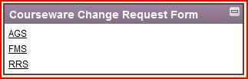  ** USER MUST HAVE ACCESS TO SHAREPOINT**
Based on the area accessed from you will see AGS, FMS, or RRS in the title area.  Complete all * areas on request.  Select OK Button | 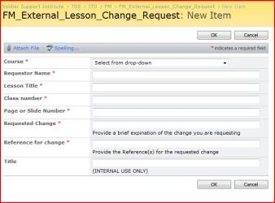
Requestor will receive a email notification of the submitted request.
Appropriate Branch Chief of ITD will receive workflow.

Branch Chief Accepts or Rejects Workflow with comments.

Rejected workflow is returned to requestor and closed.
Accepted workflows are forwarded by Branch Chief to Developer for changes.

Developer makes changes, publishes the change and Approves Workflow with comments.
Requestor receives notification of final disposition on request.

Appendix B

Course Sites Return to Course Sites
Course Site.  Course Title on top of page.  POC Email on the right hand side. | 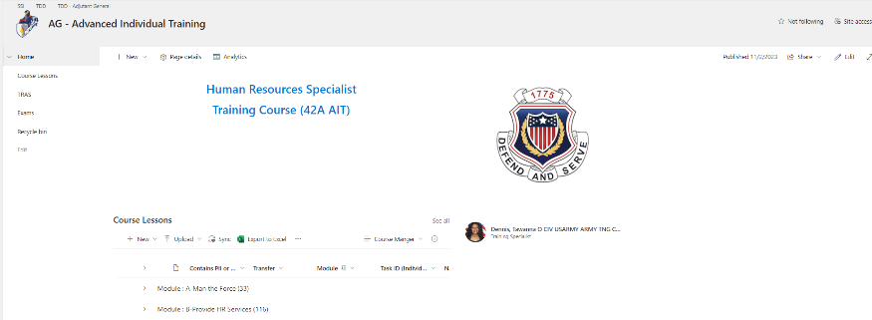
Documents  - Course Lessons (must contain all related course content and inherit permissions from Course Site).  - Exams (must contain the print ready versions of the Blackboard Exams. This file will be restricted to developer, approval authority, and TCO (as needed) only by removing all other users and Group permissions).  - General Correspondence (storage for messages and requirements to change course content and other course communications).  - Training Schedules (Master Training Schedule).  - TRAS (storage for all TRAS Documents generated in TDC). | 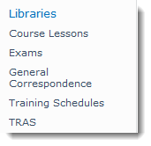
Lists.  - Calendar  - Tasks (Task list serves as the connection point between workflows and Outlook) | 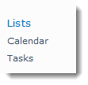
Discussions.  - Team Discussion  - (Blog type option for discussion within the course site) | 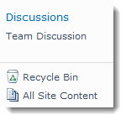  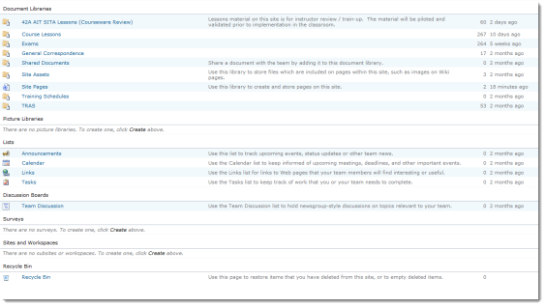
All Site Content
(allows the user to see Libraries Lists and Features not on the Quick view bar)

Appendix C

Versioning and Workflows (uploading documents)

Return to Versioning and Workflows
Uploading a Document to SharePoint  From the Course Lessons Location select “Upload”, then select “Add Document”.  From the “Upload Document screen select the “Browse button” or “Upload Multiple Files” and locate the document to be uploaded from your computer.  Enter version comments in the “Version Comments” block and select “OK”.  The audit information screen will pop up requiring the detail for the content being loaded.  This will not appear when uploading multiple pieces of content. The Developer will need to go back to the “Course_Lessons” Folder and edit each of the new items uploaded using the “Edit Properties” by selecting the check box to the left of the document and then selecting Edit Properties from the Menu. | 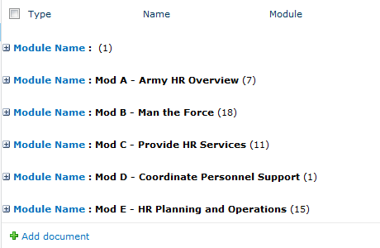  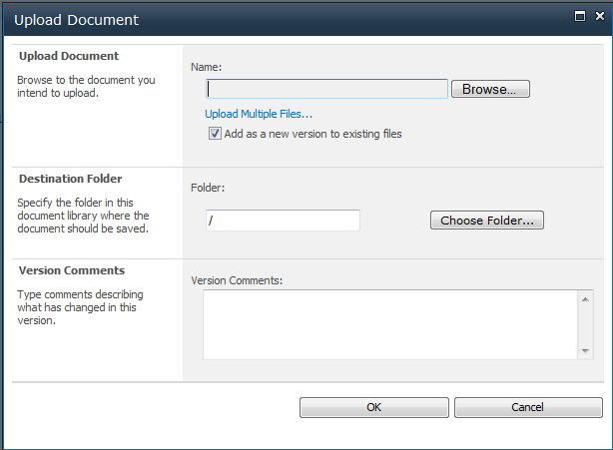  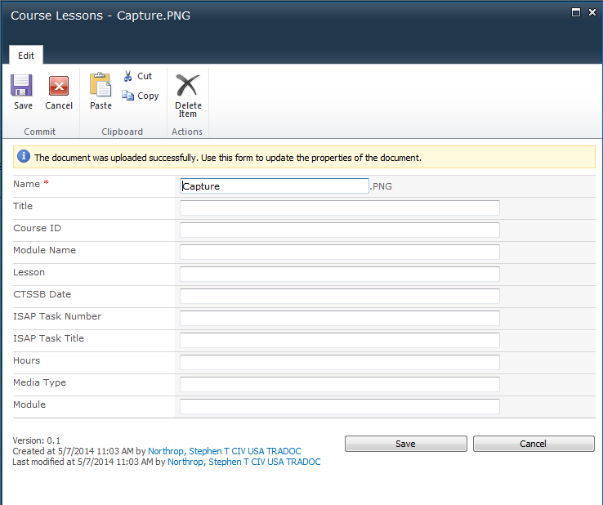  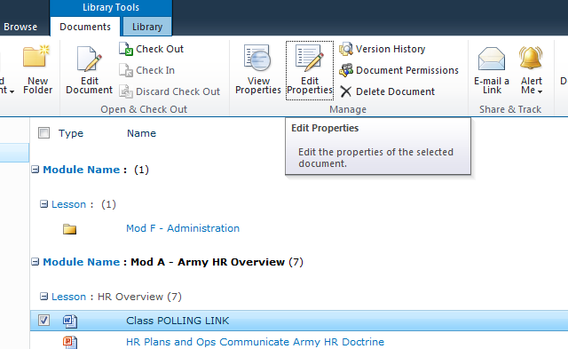
Versioning: allows the developer to work on and make updates to course content by using minor versions while the major version remains published to individuals with read only access.

A draft or working copy is any version number that carries an added value after the whole number (ie 1.1, 1.2, 1.3, 2.1, 2.2, 2.3) These are only viewable by users that have contributor rights and higher.
To move content from Minor (Draft or Pending) versions to Major (Published) versions:  Select the down arrow to the right of the name then select “Publish a Major Version”  The “Publish Major Version Screen will come up requiring you to enter “Comments” and select the “OK” button  If you are the Approver for this version, select the down arrow to the right of the name. Then select “Approve/reject””  (if you are not the Approver you must generate an approval workflow as discussed later in this Appendix).  Select “Approved” radio button from “Approval Status”  Enter Comments.  Select “OK” button. | 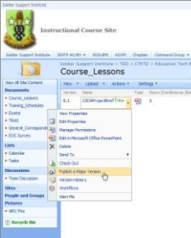  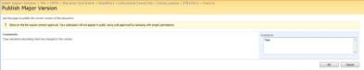  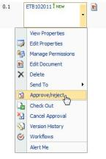  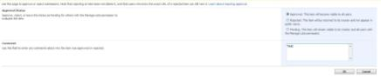
A published version is displayed as a whole number Major version (1.0, 2.0, 3.0…). Viewable by all that have access to the course site. | 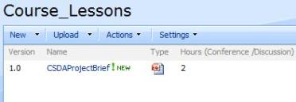
To restore a previous version:  Check out current item by selecting the drop down to the right of item and selecting checkout.  Deselect the “Use my local drafts folder “ option and select “OK” button.  Select the drop down to the right of the named file.  Select “Version History”.  Select the dropdown arrow to the right of the version you want to restore.  You will receive the following popup.  Your item will be made the next higher minor version, requiring you to check it back in and Approve using the same steps as above. | 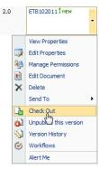  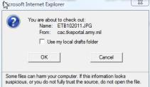  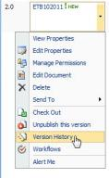  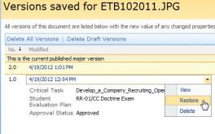  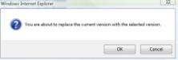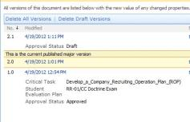
Workflows: Workflows are either for Lateral Review or Approval. | 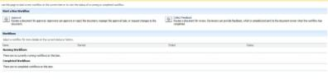
- The Lateral Review (Collect Feedback) workflow is submitted to obtain feedback from multiple people at the same time. All persons being tasked must have at a minimum contributor rights to the workflow assigned by the Training Developer. | 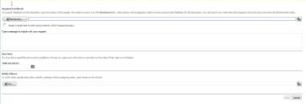
- The Approval workflow can be Parallel or Serial but, is generally Serial allowing for sequential approvals with the final Approval publishing the content as a new Major version making it viewable to all users. Persons being required to Approve content must have approver rights assigned to them by the Training Developer. | 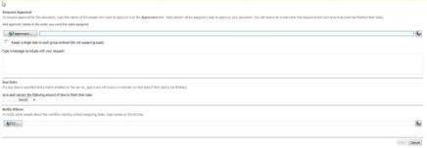
- Work flow is initiated by accomplishing the following:  From Documents -Course_Lesson Select the drop down to the right of the item.  Select the “Workflows” option.  For an Approval Workflow select “Approval” option.  Add Approvers in order of Approval first to last, the last being the overall approver. This will allow the item to publish once approved.  Add specific comments stating what has changed.  Assign suspense accounting for weekends and Holidays.  The CC line is for notification but, does not place the entries in the approval process.  Select “Start” on the bottom right.  The first person in the Approval chain will receive the workflow via email to the users Gov Mail account.  Select “3. Edit this Task.”  Due to the security restriction you may receive “The webpage cannot be displayed.” In the URL you will see that “blocked” appears at the beginning of the URL. Remove “blocked” and select the Enter key on your keyboard.  From this window you will be taken to the “Task: Please approve Xxxxx”  Selecting “this workflow task applies to Xxxx” will open the item.  Provides the Request comments.  Type Comments is for your Comments.  Other options routes task back or to another.  Once completed, on the right side at the bottom select:  Approve – allows the workflow to move forward.  Reject- sends the workflow back to the originator.  Cancel- takes no action exits out of workflow.  During and after the workflow process, the status and location of the workflow can be checked by going to the item that has the workflow assigned.  Select the down arrow to the right of the item name.  Select “Workflows.”  Select the workflow you wish to view “Approval.”  This will show all current and past actions with the requested workflow and serves as the audit trail for this document.  The Lateral Review workflow works basically the same as the Approval workflow with the following exceptions:  The reviewers receive the workflow in parallel with a Due Date, Requestor info and comments, a Feedback Block, and a Send Feedback Button. | 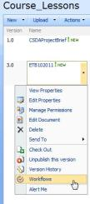  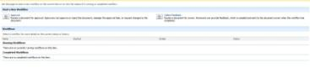  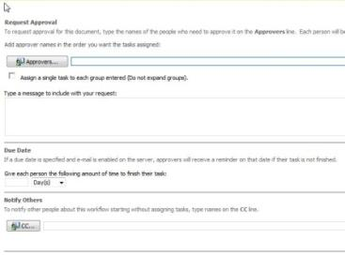  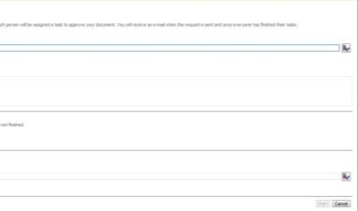  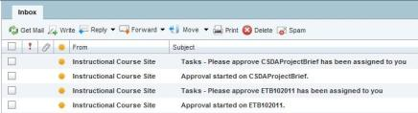  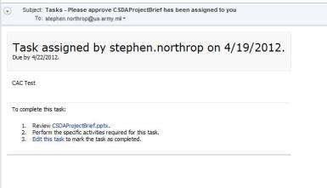  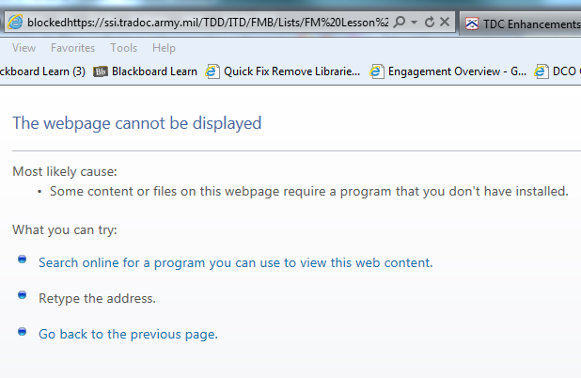  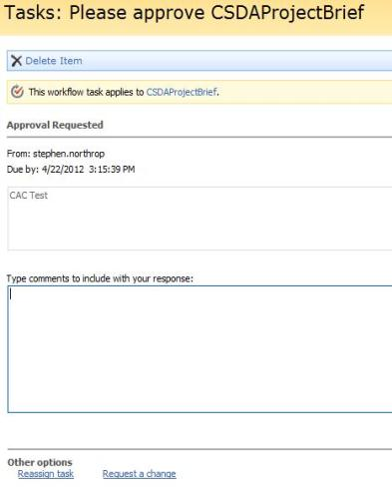  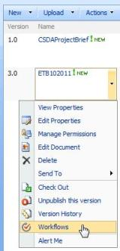  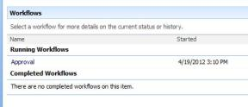  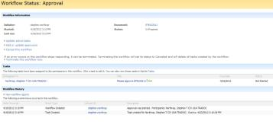  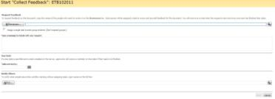
Lesson Change Request Return to Change Requests
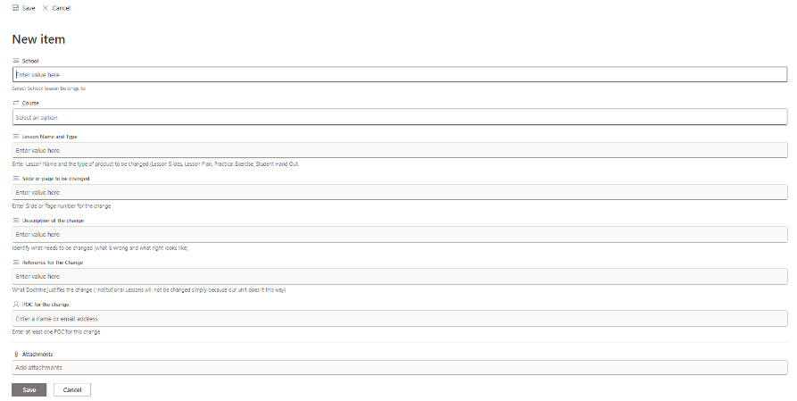
https://armyeitaas.sharepoint-mil.us/sites/TR-SCoE-SSI-TDD/Lists/Lesson%20Change%20Request/NewForm.aspx

Trouble Tickets | Return to Change Requests
Blackboard | 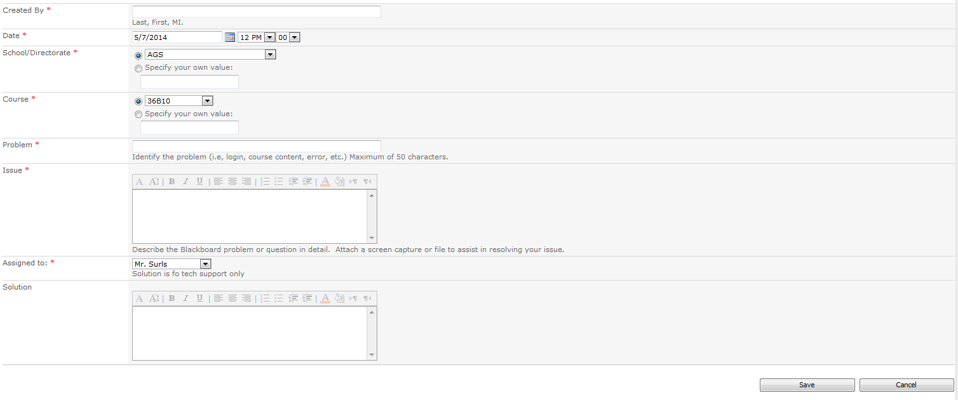
TDC | 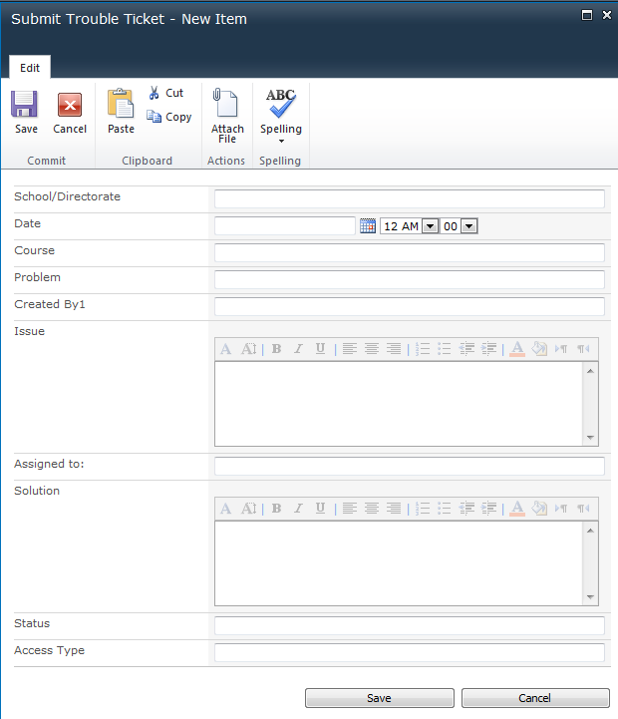
Test Reclama | Return to Change Requests
All Test Reclama’s are received within TDD by the Appropriate Chief, they are then forwarded to the available approval authorities for each school. | 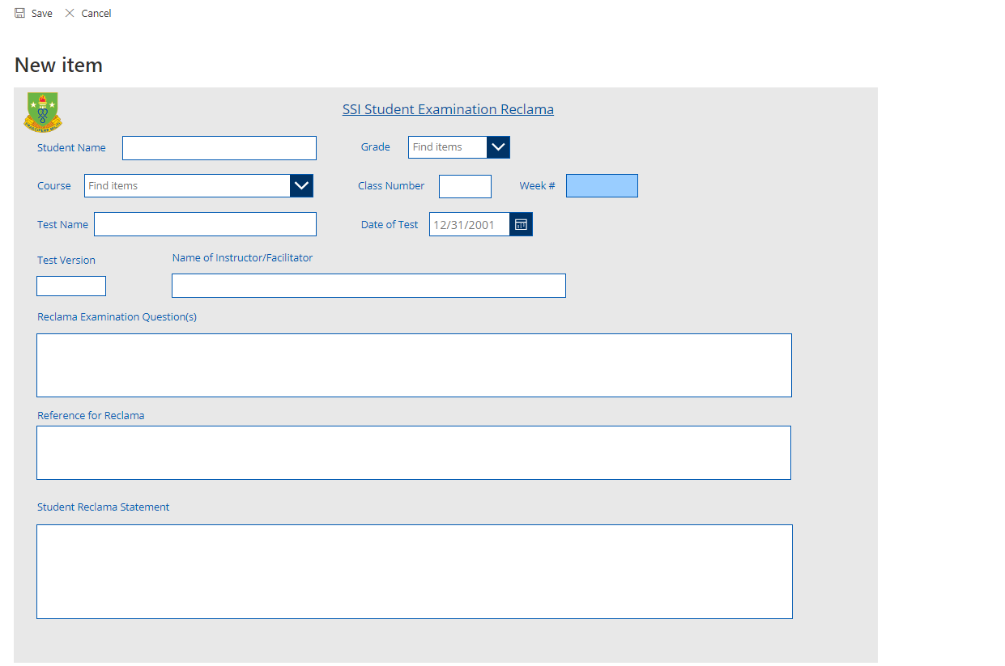  https://armyeitaas.sharepoint-mil.us/sites/TR-SCoE-SSI-TDD/Lists/Student%20Examination%20Reclama%20FJFM%2035010086a/NewForm.aspx?

Appendix D

Sync Course Lessons Folder to Outlook folder
These actions should not take place during peak hours (0900-1500)
Sync to Outlook folder
From Course Lessons Folder Select “Library” | 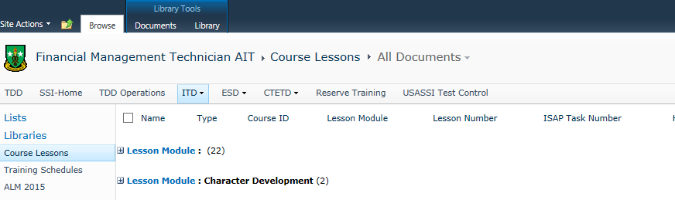
Select “Connect to Outlook” | 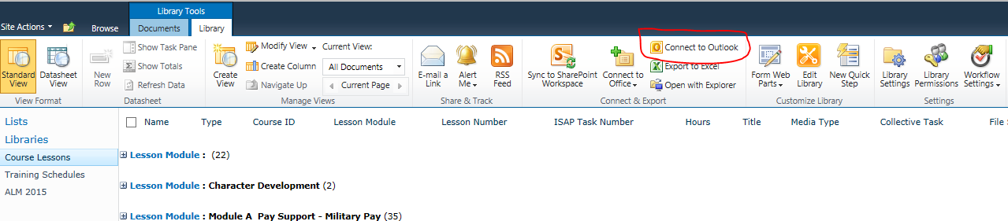
Select “Allow” internet security to open a program  Select “Allow” A website ants to open web content….. | 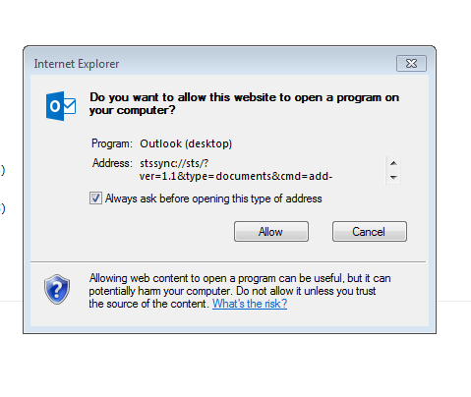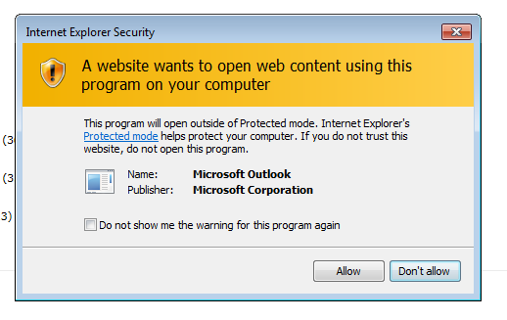
Select “Yes” Connect this SharePoint Document Library to Outlook | 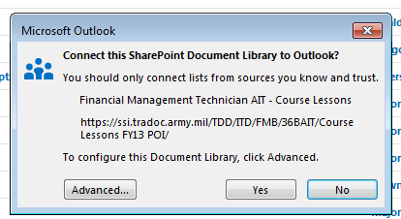
Outlook will download the Documents over a period of time | 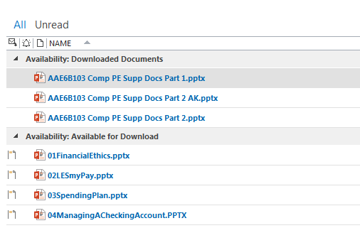
Disable Auto Sync
Select “SEND / RECEIVE”  Select “Define Send/Receive Groups” | 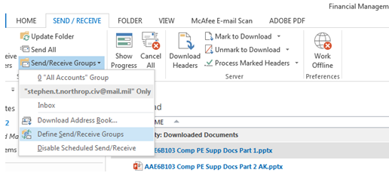
Select Edit | 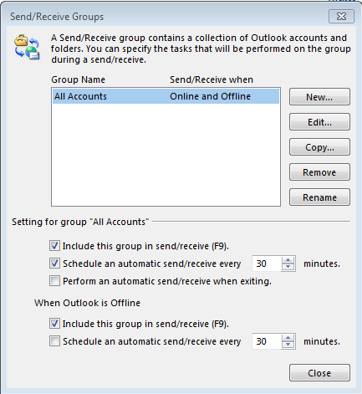
Select SharePoint located under Accounts  Deselect the check box next to your course  Select “OK” | 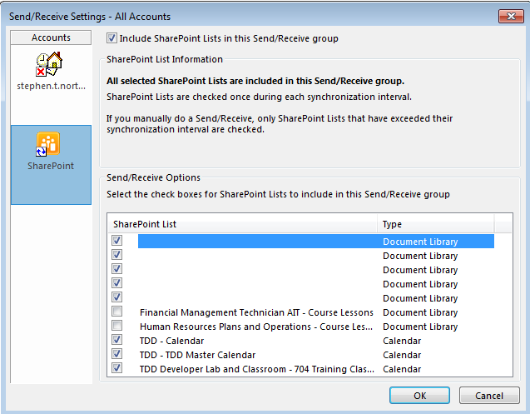
Select Close
Weekly Sync | These actions should not take place during peak hours (0900-1500)
Select Course from SharePoint list | 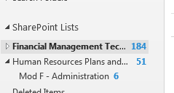
Select SEND / RECEIVE tab  Select “Update Folder” | 